**LIT TRAINING**

**Batch Name : SAP ABAP ON HANA** **NAME: UDI SARASWATHI DAY 12 ASSIGNMENT**

**EMPLOYEE ID – 46255188**

Q-1. Demonstrate a case to Design the Adobe form to display the Flight Booking details.

                     Use Tables : SFLIGHT, SPFLI, SBOOK.

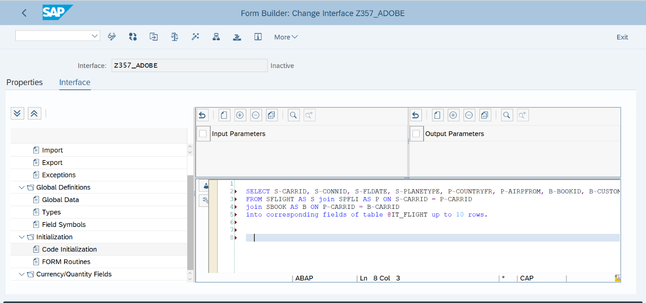

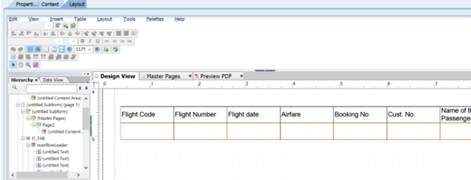

REPORT Z245_AF.     
     
tables : sflight ,spfli, sbook.     
     
data it_tab type standard table of Z245_AF

DATA  wa_oparams type sfpoutputparams.     
     
     
SELECT-OPTIONS : s_carrid FOR spfli-carrid.     
 SELECT spfli~carrid     
       spfli~connid     
       sflight~fldate     
       sflight~price     
       sbook~bookid     
       sbook~customid     
       sbook~passname     
FROM spfli INNER JOIN sflight     
ON spfli~carrid EQ sflight~carrid     
INNER JOIN sbook     
ON spfli~carrid EQ sbook~carrid     
UP TO 10 ROWS       *"selecting fields from SPFLI , SFLIGHT and SBOOK*     
INTO TABLE it_tab                                                    *"into internal table*     
WHERE spfli~carrid IN s_carrid.     
     
CALL FUNCTION 'FP_JOB_OPEN'     
  CHANGING     
    ie_outputparams       = wa_oparams            .     
IF sy-subrc <> 0.     
*\* Implement suitable error handling here*     
ENDIF.     
     
CALL FUNCTION '/1BCDWB/SM00001200'     
  EXPORTING     
*\*   /1BCDWB/DOCPARAMS        =*     
    it_tab                   = it_tab     
          .     
IF sy-subrc <> 0.     
*\* Implement suitable error handling here*     
ENDIF.     
     
     
CALL FUNCTION 'FP_JOB_CLOSE'     
*\* IMPORTING*     
*\*   E_RESULT             =*     
*\* EXCEPTIONS*     
*\*   USAGE_ERROR          = 1*     
*\*   SYSTEM_ERROR         = 2*     
*\*   INTERNAL_ERROR       = 3*     
*\*   OTHERS               = 4*     
          .     
IF sy-subrc <> 0.     
*\* Implement suitable error handling here*     
ENDIF.

OUTPUT:-

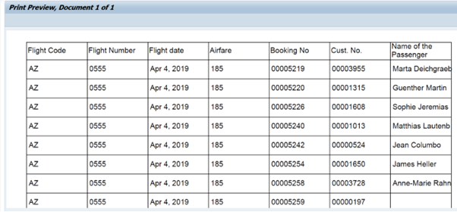

Q2:  Java Script to display footer only last page .

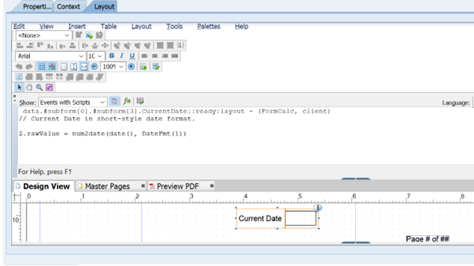

OUTPUT:-



Q-4. Demonstrate a case to use Dynamic TEXT in adobe forms.

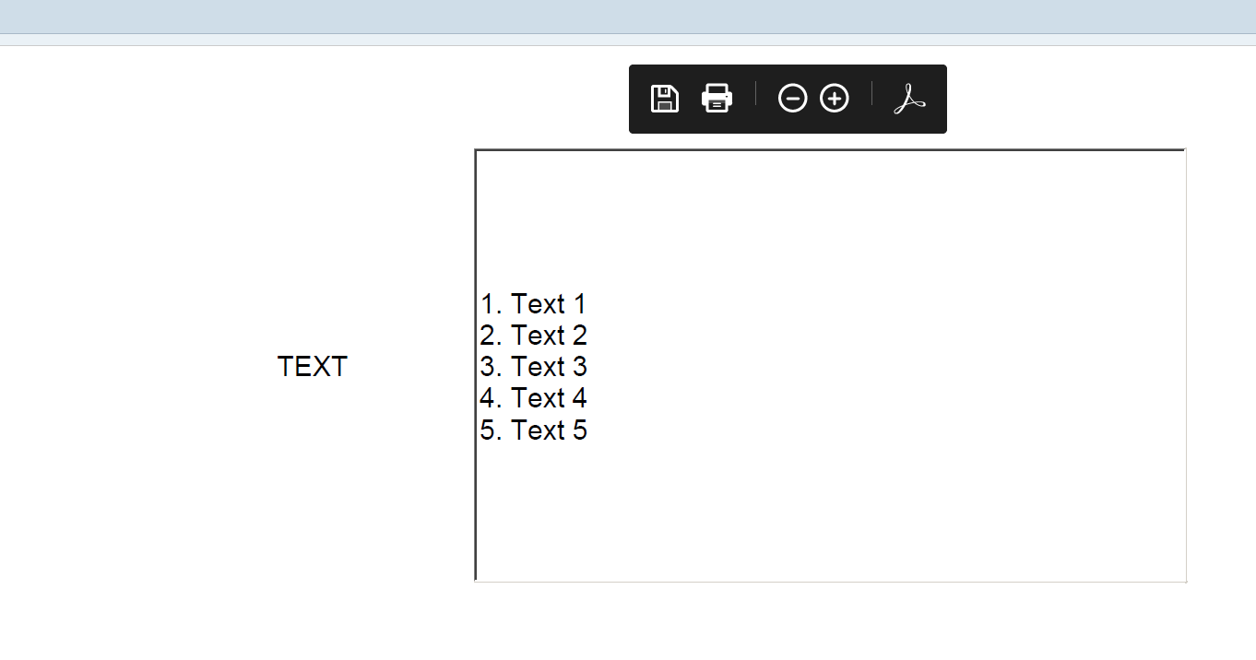  
Q-5. Demonstrate a case to use INCLUDE TEXT in adobe forms.

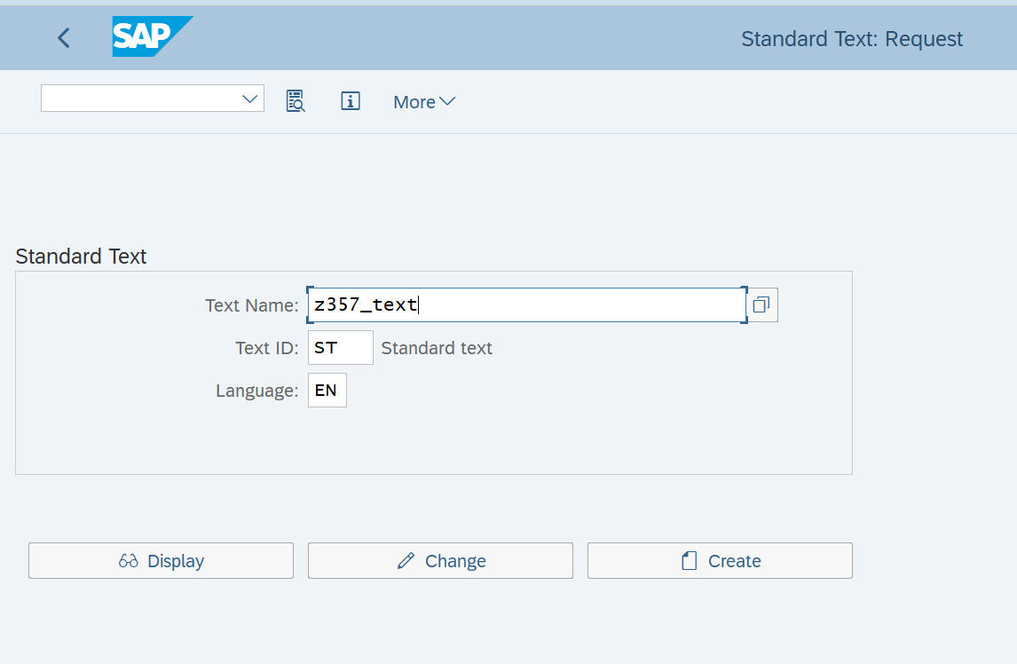

OUTPUT:-

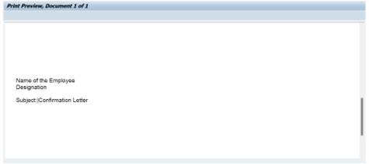

Q-6. Create a case to use image from SE78 in adobe forms.

